AWS ACCOUNT CREATION PROCESS

BY Hari SIR.

[https://portal.aws.amazon.com/billing/signup#/start/email](https://portal.aws.amazon.com/billing/signup%23/start/email)

1. **Enter EMAIL and ACCOUNT NAME (ANY NAME)**

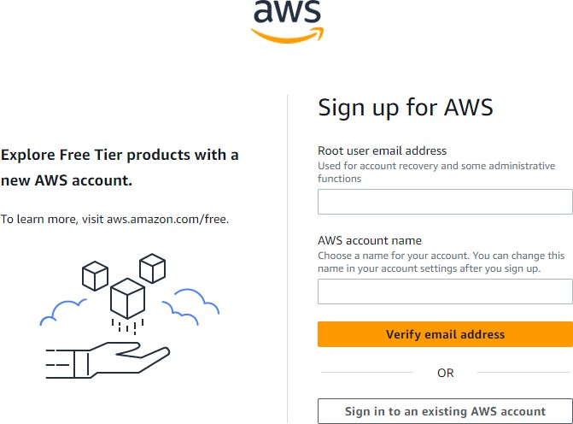

1. **Go to Mail Account for Verification code and paste here.**

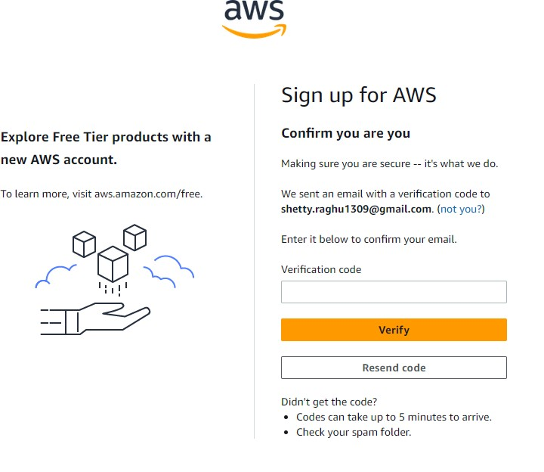

1. **Choose Personal Radio button option and fill your details.**

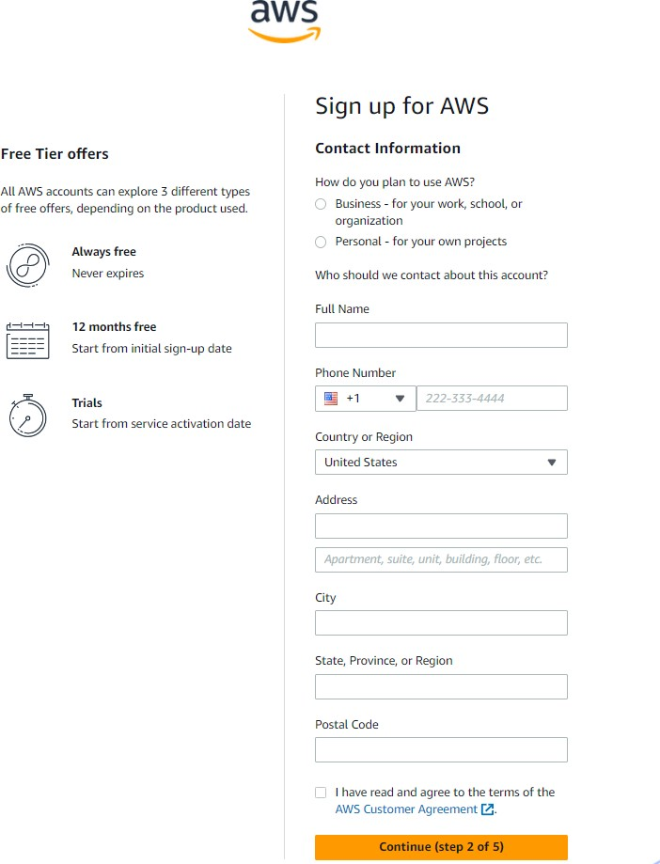

1. **Use credit card or debit card details and fill. (It will charge INR 2.0 for verifications)**

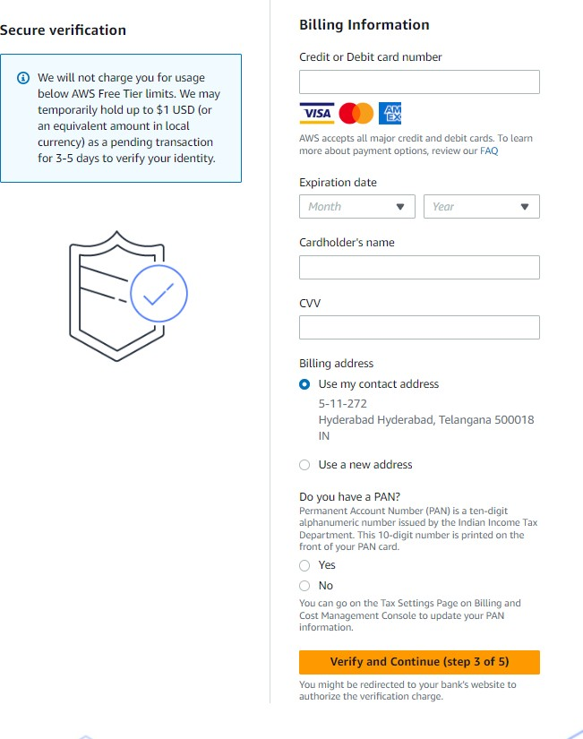

1. **Enter you contact details for verification**

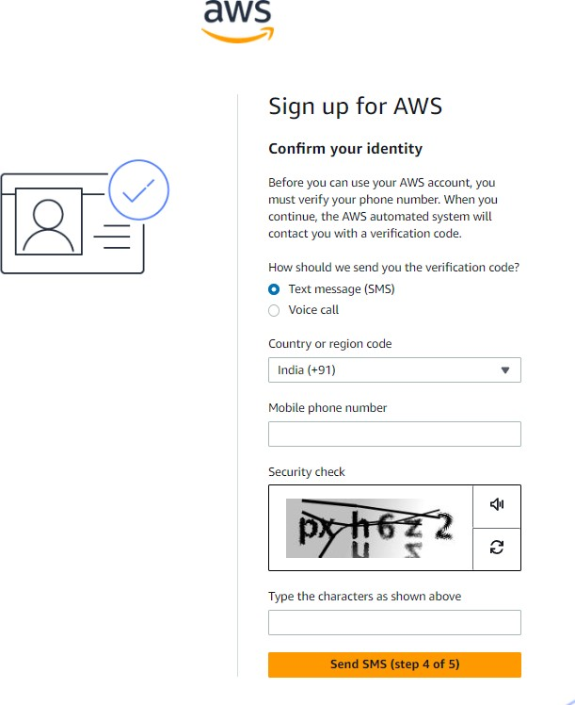

1. **Enter Verification code which you got to your mobile**

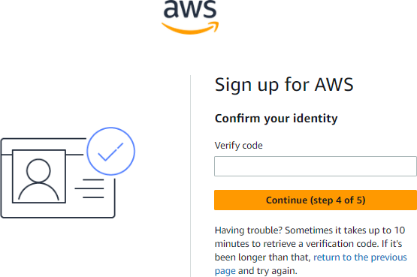

1. **Choose Free Plan option**

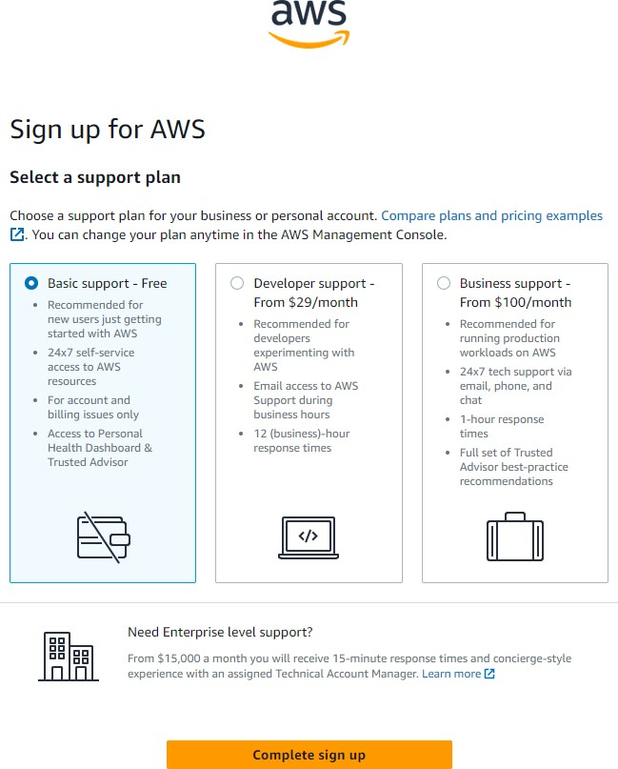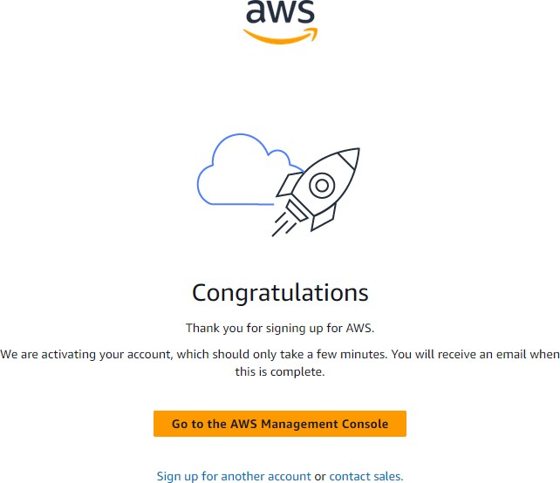

1. **Enter URL for login (or Go to AWS Console using google)**

[https://ap-south-1.console.aws.amazon.com/console/home?region=ap-south-1#](https://ap-south-1.console.aws.amazon.com/console/home?region=ap-south-1)

Email: [cheruku.harikrishna@gmail.com](mailto:cheruku.harikrishna@gmail.com)  
Call: 9666721797